Learner’s Name: Megan Mangwiro

Website:
Aims of the project
My aim of this project is to make a portfolio website to showcase/promote my work and skills to those interested alongside future employers and those who handle submissions.
Purpose of the Application
The website will present a gallery of my personal digital media work alongside projects I have created throughout this course.
Target Audience
The target audience would be those who look at admissions + future employers as they’ll need to see evidence of my work and projects. Another possible audience could be those who are interested in my work and wish to see more of it. Therefore, I must manage the needs of both audiences by making the site mobile-friendly and interactable whilst also maintaining a simple and fast feel.
Main User Interactions
-Navigating Menus
-Viewing photo and video files

Design Considerations
-Making the site design responsive to both desktop and mobile

-Add alt text to make the website accessible to those who use screen readers.

-Make the website appearance as accessible as possible. Make sure layout is simple with fonts that are easily readable.

Functional Requirements
-Navigation Bar
-Contact Form
Non-Functional Requirements
Fast loading times- Achieved with web-optimized images.

Delivery Platform (Medium)
The website must work on both desktop and mobile devices. It should also work across many web browsers. As this is simply a portfolio site, there will be no plans to create a mobile app.

Flowchart of website navigation structure goes here

Example below [remove and replace with your own]:

All Hardware and software required

Hardware | Software
Computer | Visual Studio Code
 | Procreate (Favicon)
 | Figma (Wireframing)

All Media elements used [example included, remove on submission]

Name | Type | Source | Import/manipulation details | Legal requirements | Justifications
favicon | ico | Self | Created in Procreate, exported as png and converted to ico file for web.  3698x3735  4.3MB | Fully owned by creator | Reduced dimensions and changed to ICO
character | jpg | Self | Created in Procreate, exported as jpg for web.  1337x2048  2MB | Fully owned by creator | Reduced dimensions and changed  to JPEG quality to reduce file size while maintaining image  fidelity.
emotions | jpg | Self | Created in Procreate, exported as jpg for web.  512X512  99KB | Fully owned by creator | Reduced dimensions and changed  to JPEG quality to reduce file size while maintaining image  fidelity.
Explodingheadfinal-min | jpg | Self | Created in  Photoshop, exported as jpg for web.  675x900  3MB | Fully owned by creator | Reduced dimensions and changed  to JPEG quality to reduce file size while maintaining image  fidelity.
FIRST DESIGN MOCKUP | jpg | Self | Created in Photoshop, exported as jpg for web.  675x900  3MB | Fully owned by creator | Reduced dimensions and changed  to JPEG quality to reduce file size while maintaining image  fidelity.
SECOND  DESIGN MOCK UP | jpg | Self | Created in Photoshop, exported as jpg for web. | Fully owned by creator | Reduced dimensions and changed to JPEG quality to reduce file size while maintaining image  fidelity.
horrorposter | jpg | Self | Created in Photoshop, exported as jpg for web. | Fully owned by creator | Reduced dimensions and changed to JPEG quality to reduce file size while maintaining image  fidelity.
horrorposter 2 | jpg | Self | Created in Photoshop, exported as jpg for web. | Fully owned by creator | Reduced dimensions and changed to JPEG quality to reduce file size while maintaining image  fidelity.
man burger | jpg | Self | Created in Procreate, exported as jpg for web. | Fully owned by creator | Reduced dimensions and changed to JPEG quality to reduce file size while maintaining image  fidelity.
poster1 | jpg | Self | Created in Procreate, exported as jpg for web | Fully owned by creator | Reduced dimensions and changed to JPEG quality to reduce file size while maintaining image  fidelity.
poster2 | jpg | Self | Created in Procreate, exported as jpg for web | Fully owned by creator | Reduced dimensions and changed to JPEG quality to reduce file size while maintaining image  fidelity.
instagram | png | Flaticon.com | (null) | Creative Commons Attribution | Reduced dimensions
facebook | png | Flaticon.com | (null) | Creative Commons Attribution | Reduced dimensions
twitter | png | Flaticon.com | (null) | Creative Commons Attribution | Reduced dimensions
banner2 | jpg | Self | Created in Procreate, exported as jpg for web | Fully owned by creator | Reduced dimensions and changed to JPEG quality to reduce file size while maintaining image  fidelity.
IMG_8832 | jpg | Self | Created in Procreate, exported as jpg for web | Fully owned by creator | Reduced dimensions and changed to JPEG quality to reduce file size while maintaining image  fidelity.

Figma designs

Provide screenshots of your all of your Figma Designs [mobile and desktop] and share a link to you Figma designs here

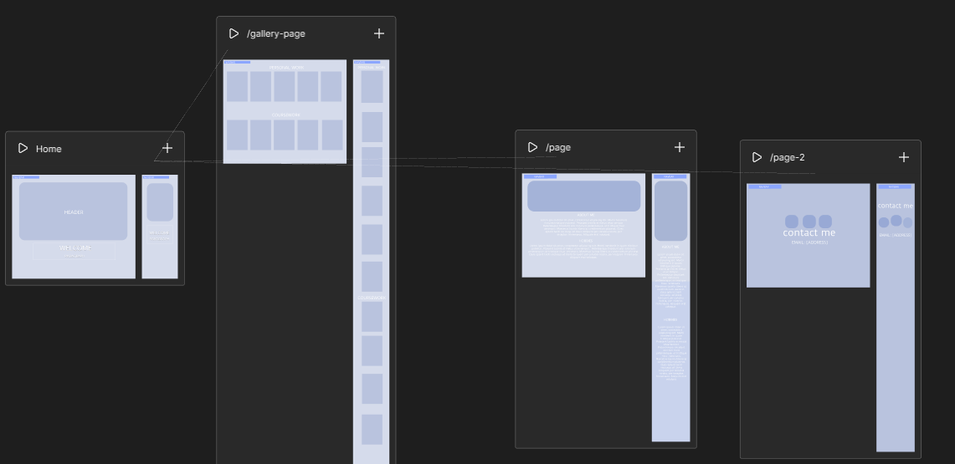

https://www.figma.com/site/sxuH6oRNgjSzdC0dtJhTuM/web-project-wireframe?t=BAJGZ7p9wPuNDklI-1
.

